UML Diagrams for ATM Machine

**CASE STUDY:- ATM MACHINE AND SYSTEM**

ATM or rather Automated Teller Machine is also called as ANY TIME MONEY by many. The ATM system is connected to banks.

The ATM is given the utmost security in terms of technology because its a stand alone system and easily prone to malicious attacks.

The Below diagrams are has come up in Mumbai University MCA exams.

Class Diagram for ATM Machine

[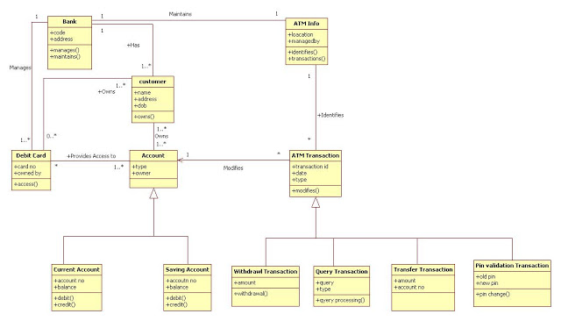](http://2.bp.blogspot.com/-t40LLtJ85z4/T5Yqv-XbxlI/AAAAAAAAATk/cfvOmqCyuRw/s1600/class+diagram+ATM.JPG)

Use Case Diagram ATM Machine

[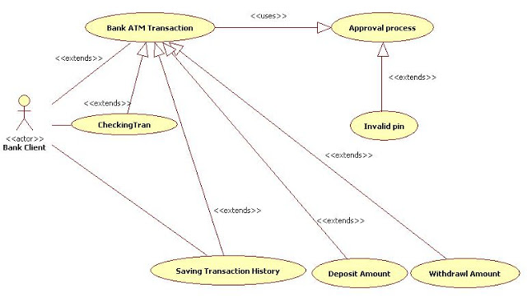](http://1.bp.blogspot.com/-zM9ToDlaWaU/T5Y39Gf1fLI/AAAAAAAAAWM/EycHo2NGwU4/s1600/Use+Case+Diagram+ATM.JPG)

Activity Diagram for ATM Machine 1

[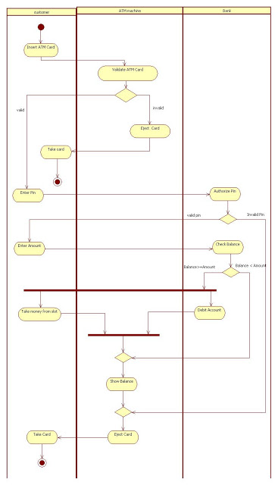](http://4.bp.blogspot.com/-uzCy2dnucC8/T5YqudQi8cI/AAAAAAAAATc/tyyGtc5EPt8/s1600/activity+diagram+ATM.JPG)

Activity Diagram for ATM Machine 2

[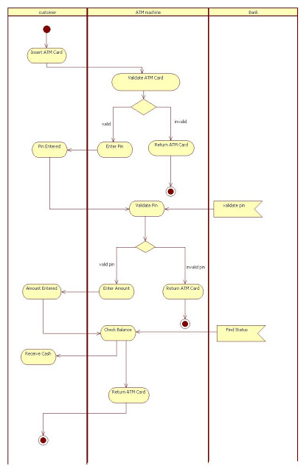](http://2.bp.blogspot.com/-8bwAoRpHS-k/T5Yqs-tYzoI/AAAAAAAAATU/umHmqaXd5xE/s1600/activity+diagram+2+ATM.JPG)

Activity Diagram for Overall ATM Machine:-

[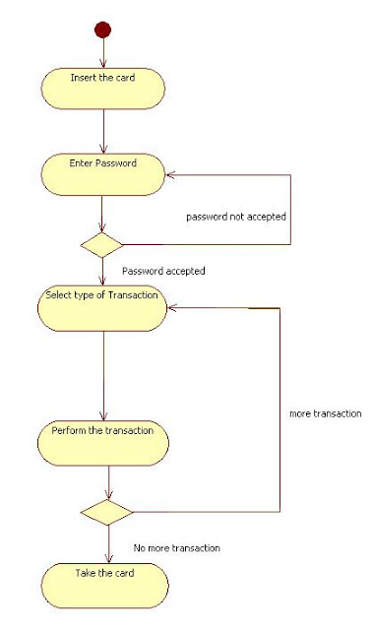](http://4.bp.blogspot.com/-1dgKPFnx_m0/T5Y3tShgSmI/AAAAAAAAAUs/ztfDINmOsWk/s1600/Activity+diagram+overall+ATML.JPG)

Activity Diagram Verify Password ATM Machine:-

[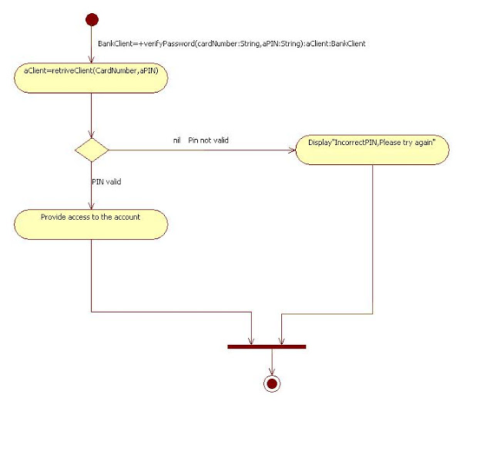](http://3.bp.blogspot.com/-CMtEe_3zCys/T5Y3uZ31ycI/AAAAAAAAAU0/HjGxqNX4i10/s1600/Activity+diagram+verify+password+ATM.JPG)

Sequence Diagram for ATM Machine :-

[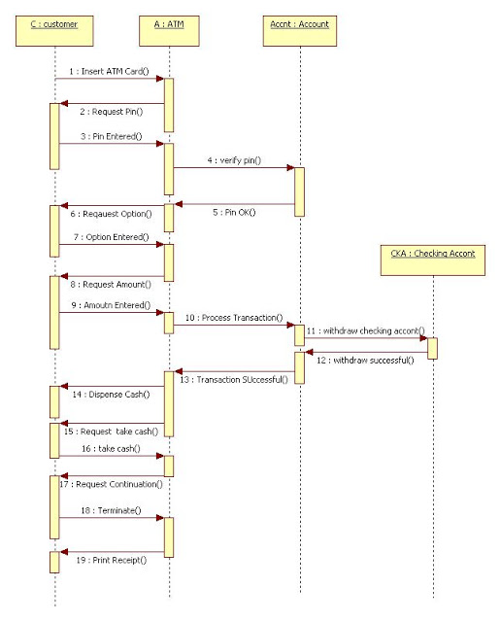](http://2.bp.blogspot.com/-WOiPrn35q7M/T5YqxMm6UqI/AAAAAAAAATs/PpanrX3ZFpg/s1600/sequence+diagram+ATM.JPG)

Sequence Diagram for Invalid Pin ATM Machine:-

[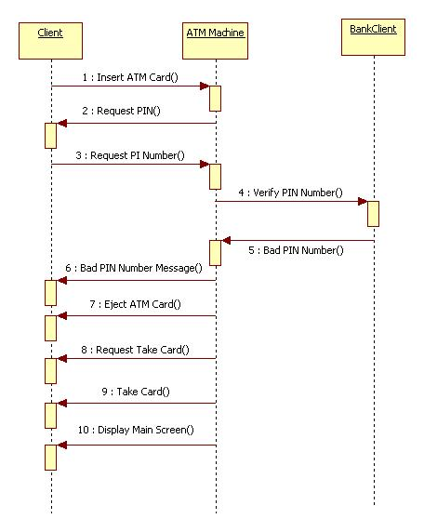](http://4.bp.blogspot.com/-Gznql7ER9Fo/T5Y34SXPXqI/AAAAAAAAAVs/hLwQgCBLnTY/s1600/Sequence+diagram+for+invalid+ATM+Pin.JPG)

Sequence Diagram ATM withdrawal:-

[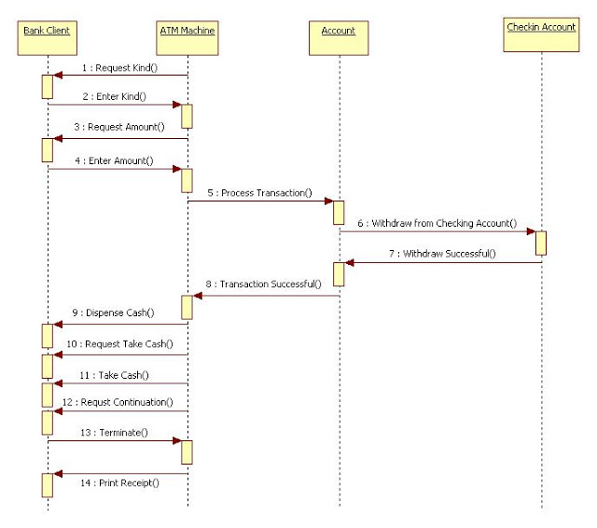](http://4.bp.blogspot.com/-_Bb-EHhGfxM/T5Y33FBdlbI/AAAAAAAAAVk/iOMrz8hrD4w/s1600/Sequence+Diagram+for+Withdrawal+ATM.JPG)

Collaboration Diagram For ATM machine:-

[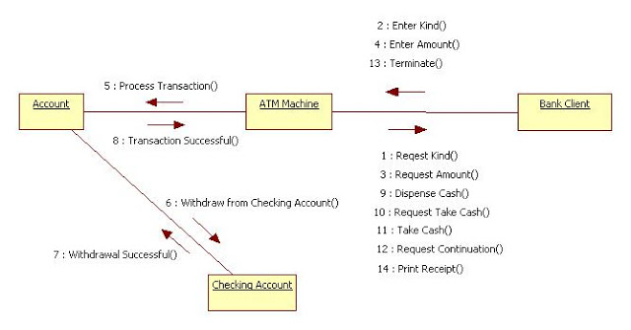](http://1.bp.blogspot.com/-32WbR33m2M8/T5Y3xHcGIBI/AAAAAAAAAVE/DGLBwIJqVnQ/s1600/Collaboration+Diagram+for+ATM+Machine.JPG)

Collaboration Diagram for ATM withdrawal :-

[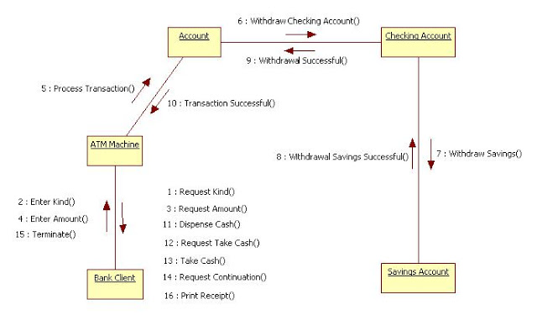](http://3.bp.blogspot.com/-GGeZLtsPybw/T5Y3yriG7gI/AAAAAAAAAVM/joVJLuU5cmI/s1600/Collaboration+diagram+for+withdrawal+ATM.JPG)

State Diagram for One Transaction ATM machine:-

[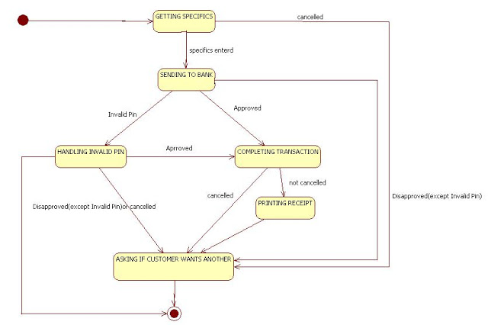](http://1.bp.blogspot.com/-KUy_piLkx8s/T5Y38BLaoZI/AAAAAAAAAWE/5mxNFb-lymQ/s1600/State+diagram+for+one+transaction+ATM.JPG)

State Diagram one Session ATM Machine:-

[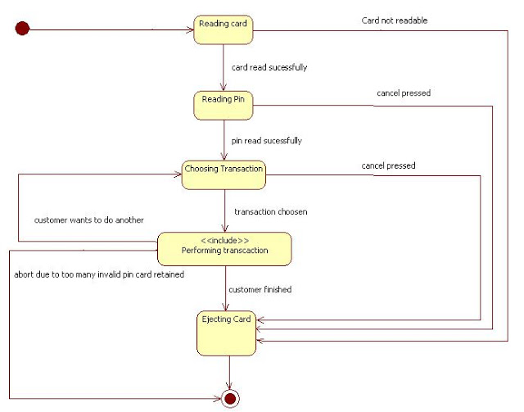](http://4.bp.blogspot.com/-nWjkEO04xds/T5Y35Q73L0I/AAAAAAAAAV0/LQUBAnDHaG0/s1600/State+Diagram+for+one+Session+ATM.JPG)

Component Diagram ATM Machine:-

[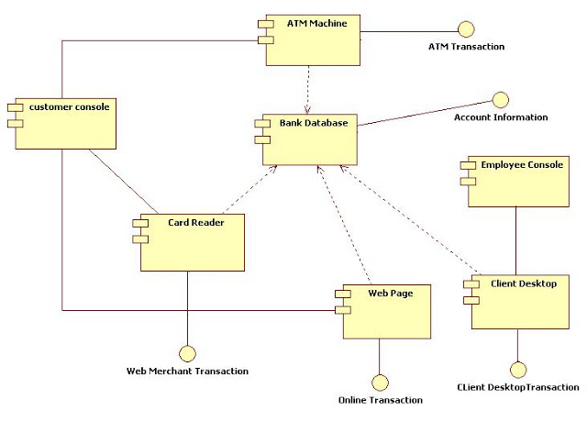](http://3.bp.blogspot.com/-Wdmym4LnpUo/T5Y3z8H6eDI/AAAAAAAAAVU/XxRvmfpwvB8/s1600/Component+Diagram+ATM.JPG)

Deployment Diagram ATM Machine :-

[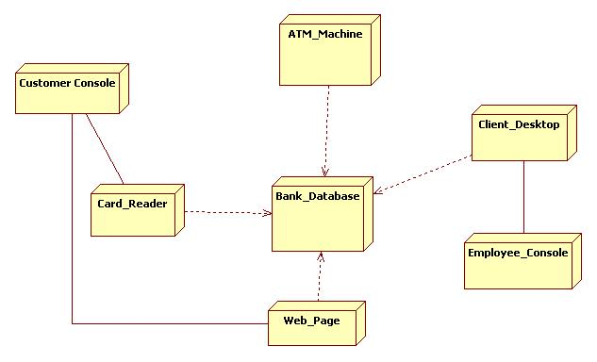](http://2.bp.blogspot.com/-qSKxb9RhKxs/T5Y31Hzgo1I/AAAAAAAAAVc/LM3imX2sSfs/s1600/Deployment+Diagram+ATM.JPG)